**VCS Task**

**Task Description:**

Establish a new directory, populate it with script files, initiate an empty repository on GitHub, convert the local directory into a Git repository, and link it to GitHub for pushing the code into the repository.Perform merge, rebase, stash commands in following github repo.

**🡪 New Directory with script files;**

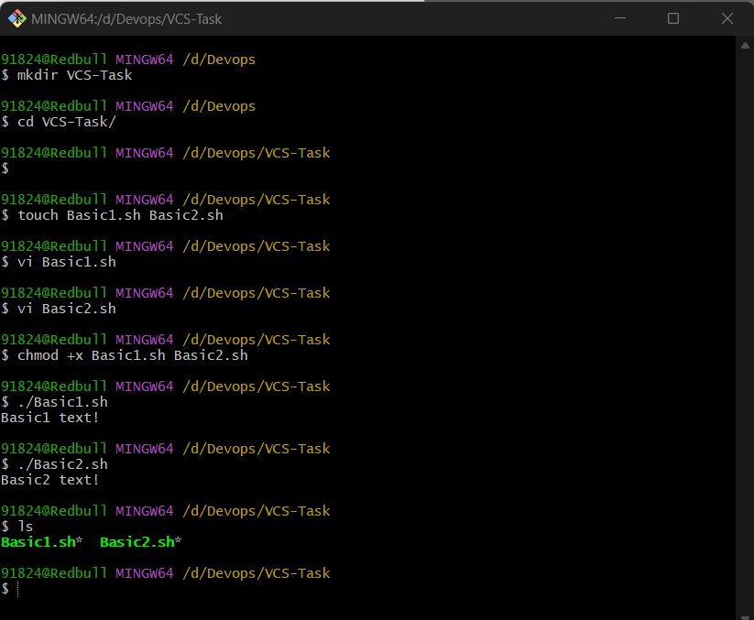

**🡪Linked it to GitHub for pushing the code into the repository using the 'git init' command."**

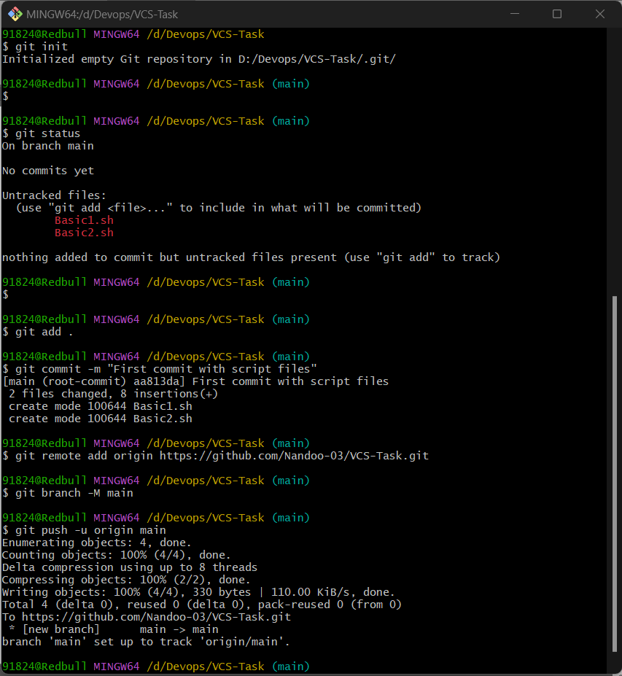

**🡪Github Remote Repositiry:**

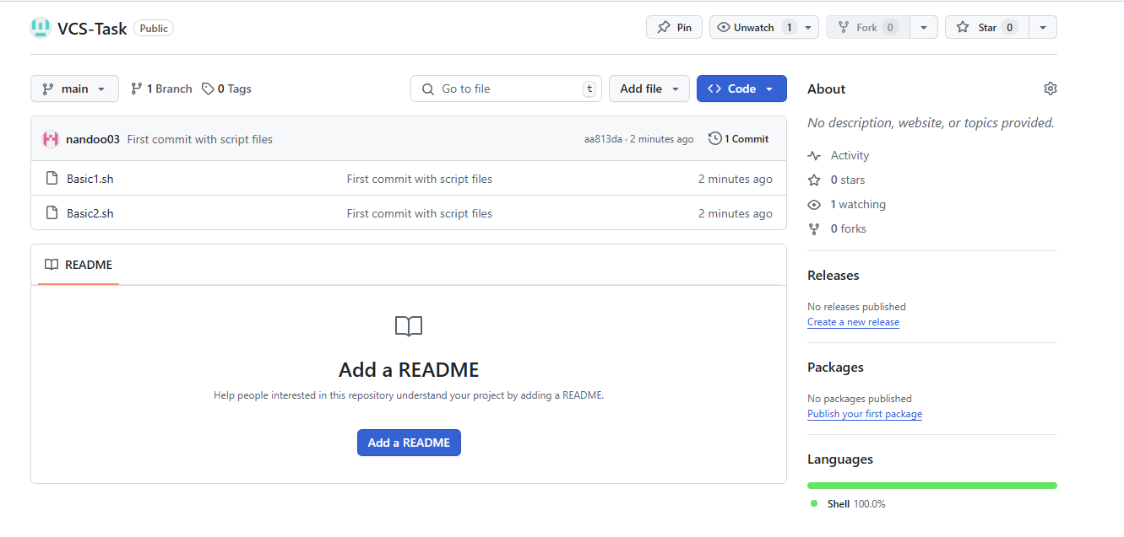

**Merge Operations:**

**Main Branch:**



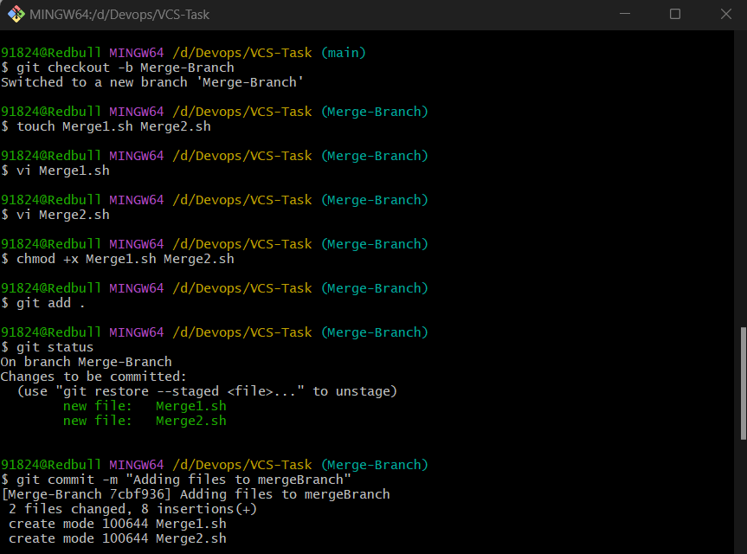

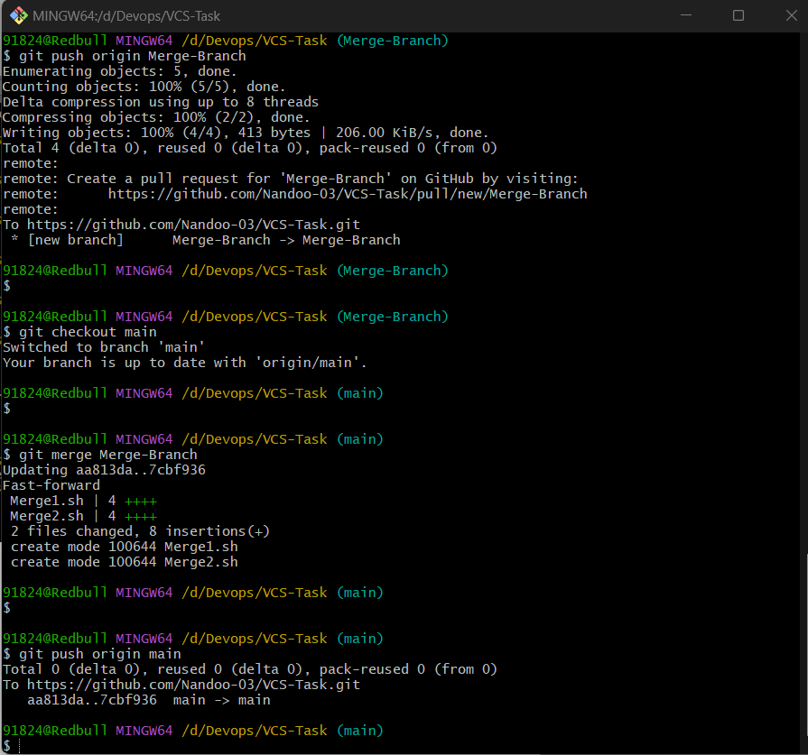

**Merge-Branch:  
->** **Adding files to the merge branch before performing a Git merge**

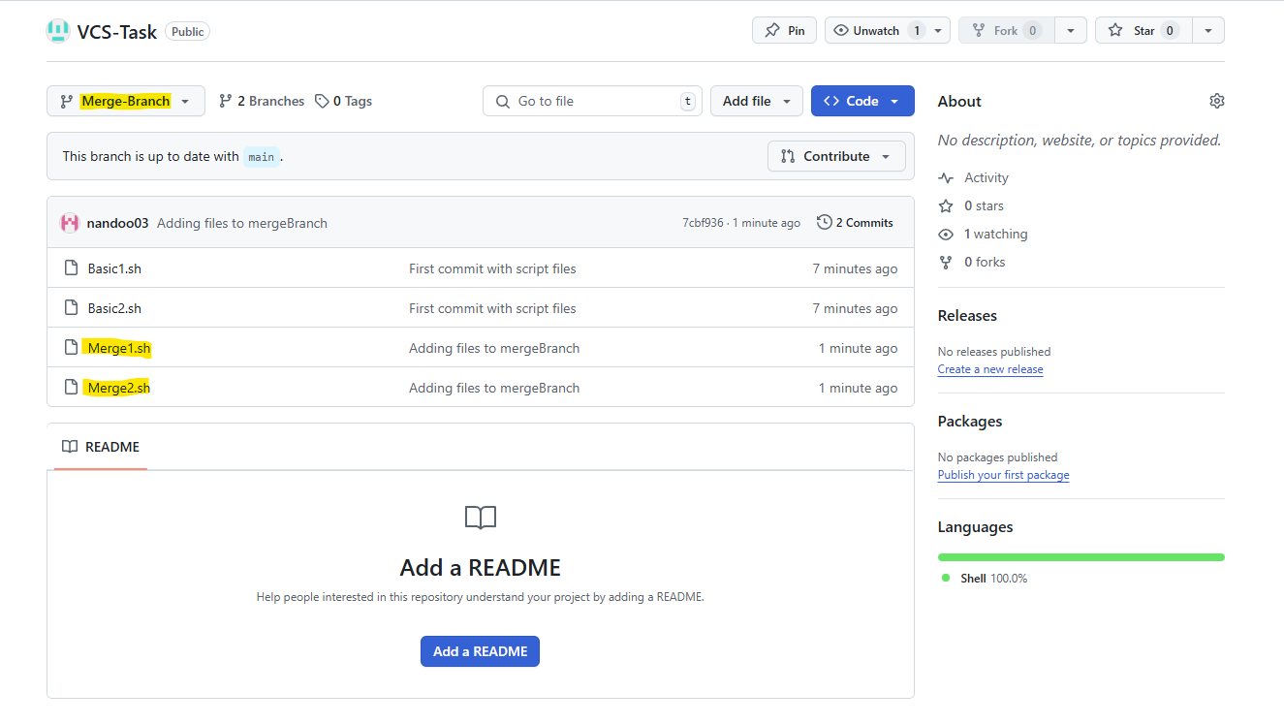

**After performing merge operations:  
Main Branch:**

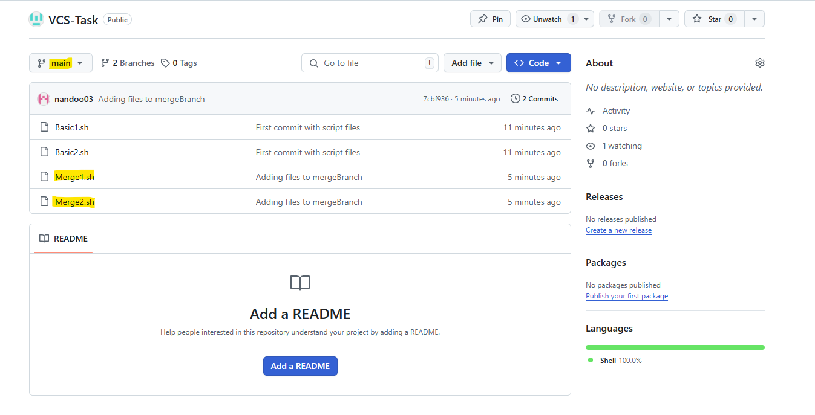

**Rebase Operations:  
Before Rebase to Main Branch,**

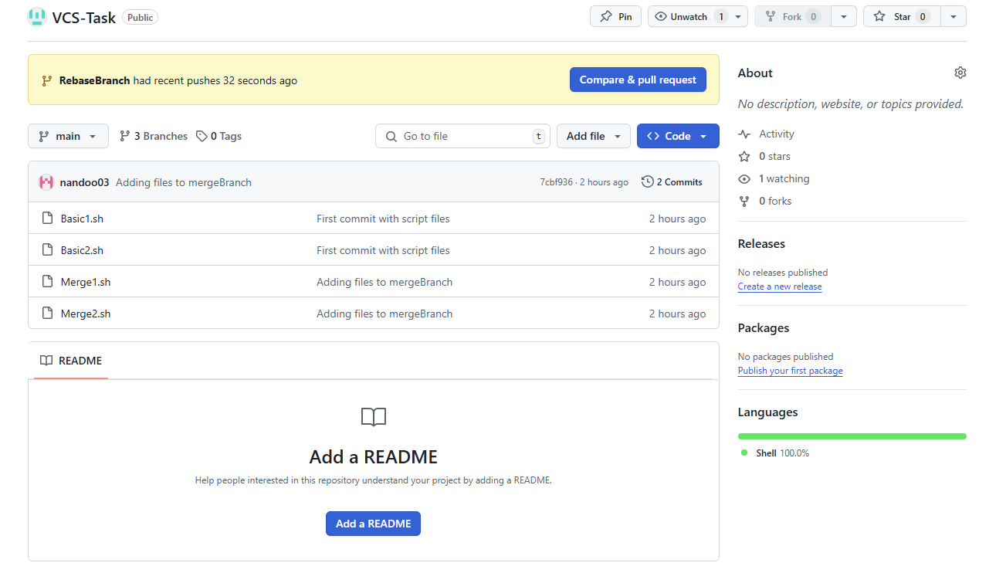

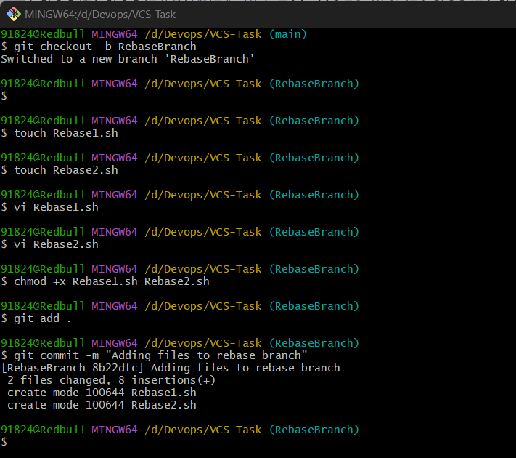

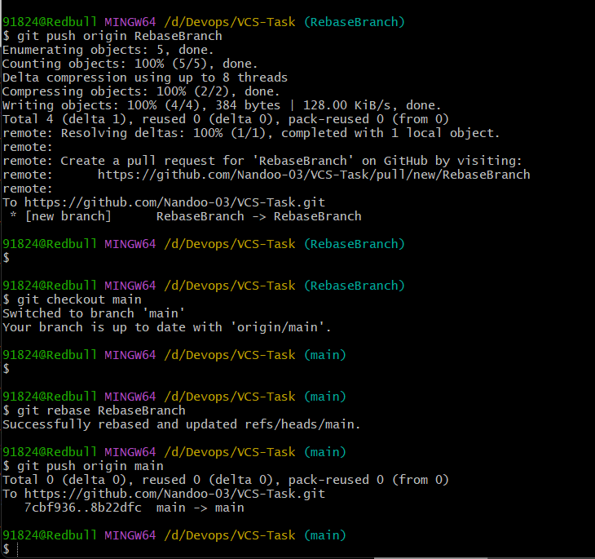

**After Rebase to Main Branch,**

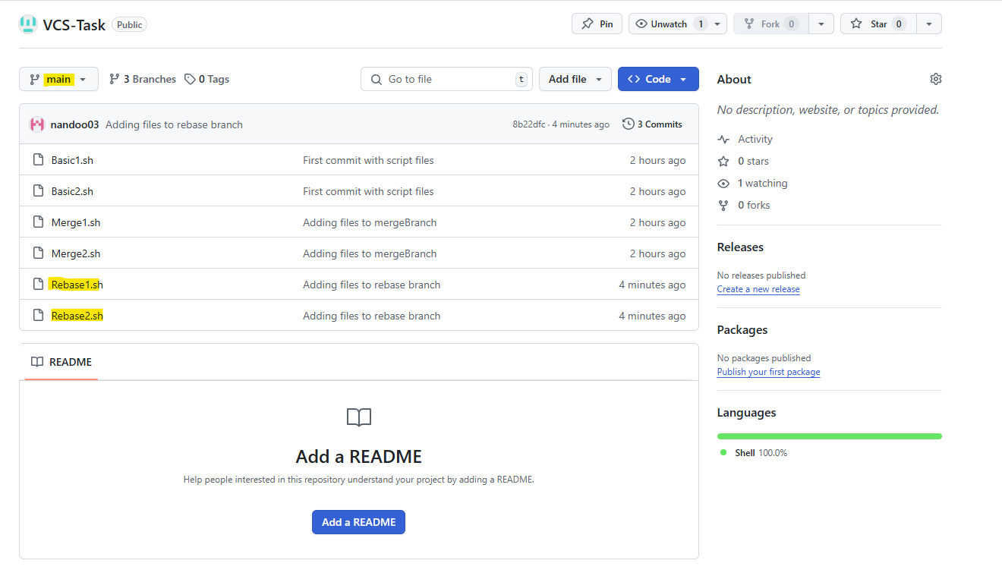

**Stash Operations:**

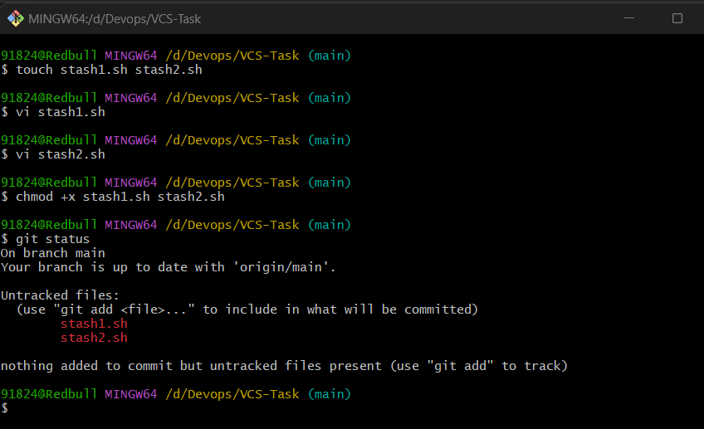

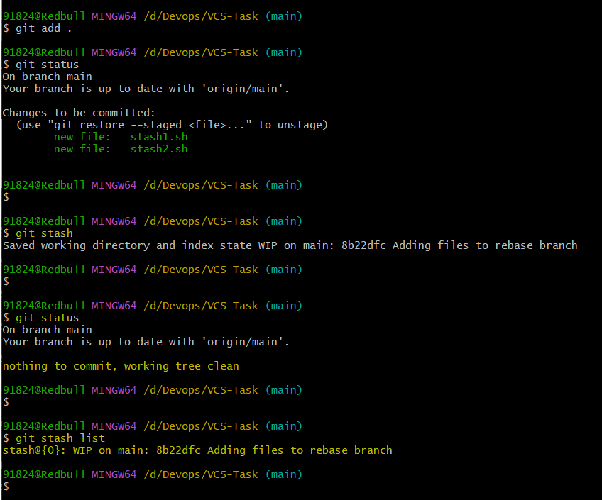

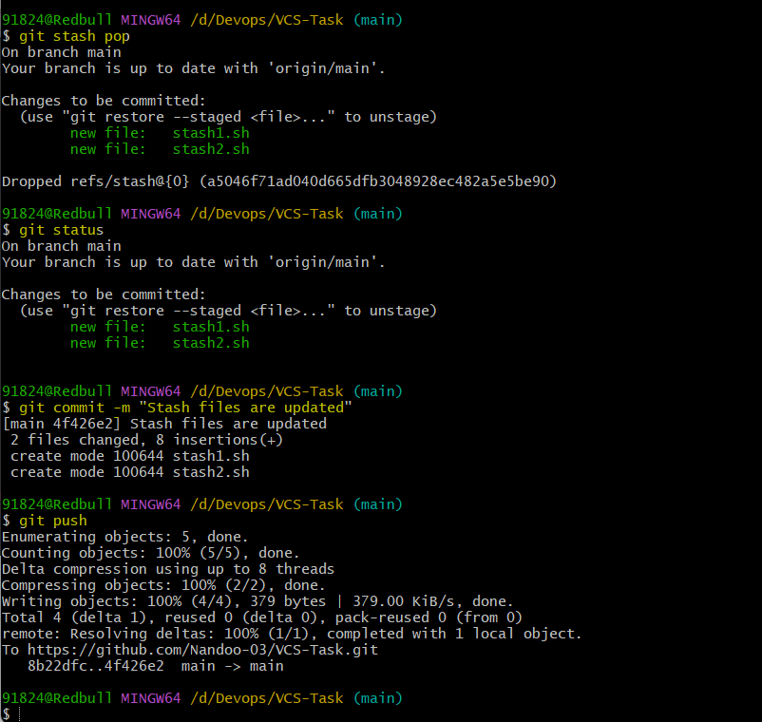

**Remote Repository:**

All files are pushed to main branch,

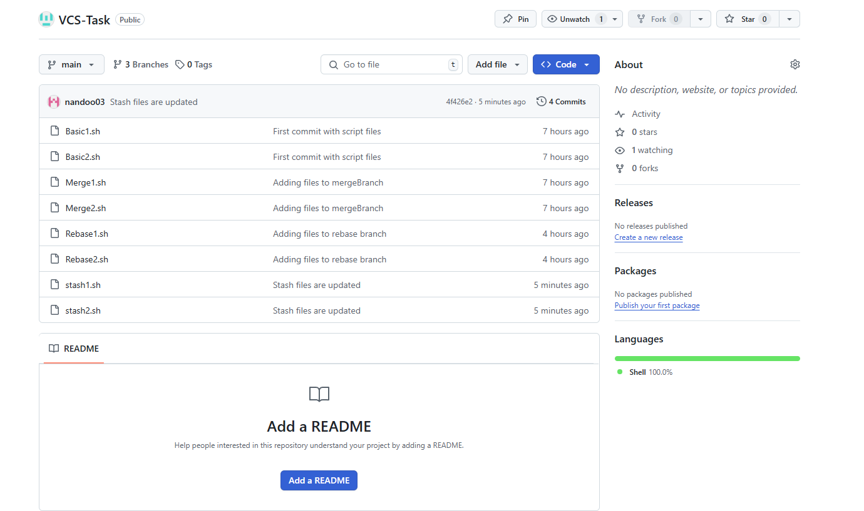

**All Commits:**

**Main Branch;**

